|  |  |
| --- | --- |
|  |  |
| Fracture Mechanics Programme | |
| User Manual | |
| December 22, 2019 | |



|  |  |  |  |  |  |
| --- | --- | --- | --- | --- | --- |
| Rev | Description | Date | Prep | Chk'd | Apprv'd |
| 01 | New Document |  |  |  |  |
|  |  |  |  |  |  |
|  |  |  |  |  |  |

Revision History

|  |  |  |  |
| --- | --- | --- | --- |
| Rev | Description | Section | Pages |
| 01 | New document | - | - |
|  |  |  |  |
|  |  |  |  |

CONTENTS

1 INTRODUCTION 3

2 Summary 3

2.1 FEA Improvements 3

2.1.1 Close out Actions Reporting 4

3 Fracture Mechanics 5

3.1 General Methodology 5

3.2 Theory 6

3.2.1 Flaw Resistance 6

3.3 Flaw Characterization 6

3.3.1 Growth 7

3.4 Paris curves 7

3.4.1 Data 7

3.4.2 Unit Conversion 8

3.4.3 Guidance 8

3.5 Result Trends Based on Past Experience 8

3.5.1 Technical Papers 8

3.5.2 Fracture Mechanics App 9

4 BS7910 2013 14

4.1 FAD 14

4.2 Flaw Geometries 15

4.3 Stress Intensity Solutions 19

4.4 Reference Stress 19

5 references 21

Appendix A – PROGRAM HISTORY 21

5.2 Revision History 21

Appendix B - App Flowchart 21

B.1 evaluate_FAD 21

B.2 get_initial_flaw_for_fatigue_loading 21

Appendix C - ERROR LOG 22

C.1 Calculation Errors 22

Appendix D -test cases. 22

# INTRODUCTION

TBA

# Summary

Python Fatigue analysis package

<https://github.com/gunnstein/fatpack>

## FEA Improvements

|  |  |  |  |  |
| --- | --- | --- | --- | --- |
| **S.No** | Flaw Type | Flaw Orientation | Scope | Status |
|  |  |  |  |  |
|  |  |  |  |  |
|  |  |  |  |  |
|  |  |  |  |  |
|  |  |  |  |  |
|  |  |  |  |  |
|  |  |  |  |  |
|  |  |  |  |  |
|  |  |  |  |  |
|  |  |  |  |  |
|  |  |  |  |  |
|  |  |  |  |  |
|  |  |  |  |  |
|  |  |  |  |  |
|  |  |  |  |  |
|  |  |  |  |  |
|  |  |  |  |  |
|  |  |  |  |  |
|  |  |  |  |  |
|  |  |  |  |  |
|  |  |  |  |  |
|  |  |  |  |  |
|  |  |  |  |  |
|  |  |  |  |  |
|  |  |  |  |  |
|  |  |  |  |  |
|  |  |  |  |  |
|  |  |  |  |  |
|  |  |  |  |  |
|  |  |  |  |  |
|  |  |  |  |  |
|  |  |  |  |  |

### Close out Actions Reporting

Run riser analysis models

Generate Shear7 files

|  |  |  |  |  |
| --- | --- | --- | --- | --- |
| **S.No** | Name | Description | Scope | Status |
| 1 | Paris curve customization | Paris curve should be customized based on the flaw type (eg: embedded flaw should use steel curve in air while external may use steel in seawater with CP) |  |  |
| 2 |  |  |  |  |
| 3 |  |  |  |  |
| 4 |  |  |  |  |
| 5 |  |  |  |  |
| 6 |  |  |  |  |
| 7 |  |  |  |  |
| 8 |  |  |  |  |
| 9 |  |  |  |  |
|  |  |  |  |  |
|  |  |  |  |  |
| 4 |  |  |  |  |

Common Errors

Improvements:

# Fracture Mechanics

## General Methodology

* Analysis is performed based on BS 7910
* Flaw Type
  + Surface
    - Internal
    - External
  + Embedded
  + Through-thickness
* Determine end of life fracture limits.
  + Construct a Failure assessment diagram (FAD) using (unstable fracture limit and local plastic collapse limit)
  + Luders platue may lie change FAD limits at high load ratio
  + Requires extreme loads to be used (80% of yield strength driven by operating limits or 100% yield – riser failure is acceptable beyond this)
* Conduct fracture crack growth analysis
  + Use Paris curves
    - Marine with cathodic protection
* Key parameters for fracture analysis
  + SCF.
    - Methodologies include
      * Connelly & Zettlemoyer
      * DnV
    - Hi-lo of wall thickness
    - Out of roundness
    - Wall thickness variation
  + CTOD (crack tip opening displacement)
  + Material properties
    - Yield/tensile ratio
    - Fracture toughness
    - Failure mode (unstable growth, plastic failure etc.)
  + Residual stress
  + Welding standards
    - Determine SCF (based on wall thickness tolerance, out of roundness, hi-lo)
    - Heat input etc. that drive the residual stress
    - Post weld heat treatment (PWHT)
* Determine flaw aspect ratio conbinations to determine maximum acceptable intial flaw size that meets the target design life
* Outcomes
  + Cause of the flaw and remedial action required
  + Weld acceptance criteria
  + Determine benefits in weld or fabrication improvements i.e. drive welding procedures
  + Material testing requirements

## Theory

### Flaw Resistance

* Unstable crack growth
* Leak before beak
* Plastic limits
* Temperature dependent creep growth rate

The failure assessment diagram (FAD) is

* Based on fracture mecahnics principles
* Vertical axis is applied load (stress intensity factor, fracture toughness etc)
* Ratio of primary load applied to plastic collapse load
* A failure assessment line is plotted to show the limits
* A flaw and crack growth (locus of points) are plotted on the FAD

In BS 7910, three (3) assessment options are provided.

* Option 1:
* Option 2:
  + Refined properties
  + Advanced procudure
* Option 3:
  + Refined properties
  + Advanced procudure

## Flaw Characterization

Flaw dimensions and interaction

In high strength/low toughness materials, the bounding flaw might not provide sufficient conservatism. Thereforem the meaximum depth of the flaw for surface falws or larger of the two

Orthogonal flaws

See Clause 7.1.2

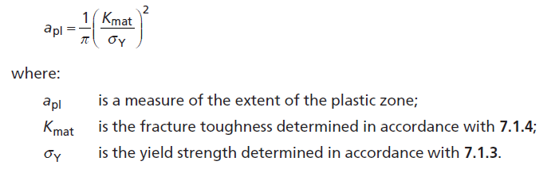

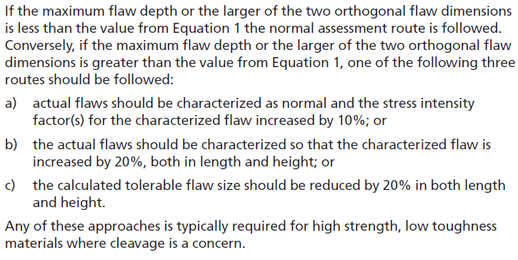

### Growth

Crack growth rate (da/dn)

Threshold Kth

is the fatigue crack growth rate, mm/cycle of loading

Stress intensity factor range, N/mm1.5

A, m : constant and exponent parameters to define the crack growth relationship

## Paris curves

### Data

### Unit Conversion

### Guidance

* For drilling riser analysis,
  + For internal and external flaws, utilize paris curve for steel in marine enveironment with cathodic protection at -850 mV
  + For embedded flaws, utilize paris curve for steel in air

## Result Trends Based on Past Experience

### Technical Papers

* The limiting flaw size reduces (by a factor of 2) for surface flaws and internal surface flaws
* Residual Stress
  + Residual stress to yield stress profiles drive the fracture mechanics
  + Utilizing yield stress for residual stress may be considered over conservative
  + Utilizing accurate residual stress profile is challenging to obtain
* Embedded flaw sizes are lmited by load ratio (which do not include residual stress effects)
* Flaw size
  + Typically defined by aspect ratio
  + The end of life flaw limits drive the initial allowable flaw size
  + The higher the growth rate, the less sensitive the intial flaw size. The change in residual stress may be less critical in areas of high fatigue growth rate due to high growth rate
* CTOD = 0.254 mm (1/100th of inch)
* Km = 1.16
* Safety factor = 5 (for production) and safety factor = 3 (for service)

For pipelines:

* Internal surface flaws typically have larger tolerable defects heights than external surface flaws
* Cicumferential external surface flaws have tolerable defects heights than axial flaws
* For axial surface flaws:
  + The acceptable flaw size is more sensitive to misalignment on internal flaw than external flaw
* For circumferential surface flaws:
  + The misalignment has more impact on the short (< 70 mm) external flaws
  + The misalignment has more impact on the long internal flaws

### Fracture Mechanics App

#### Time Marching

Proposed Method:

* Utilize constant stress intensity solution file to determine the a_start (initial flaw size)
  + Utilize coarse time step of 0.5 hours (20 years?)
  + Reduce the flaw by 20% (factor by 0.8)
  + Round down the start flaw size to 1 decimal.
  + Utilize this as starting solution for stress intensity table solution
  + Rerun to find the starting solution

Pure time marching sometimes does not give required solutions as the time step may not be sufficient to attain solution at certain min values.

The minimum allowable flaw depth is monotonically corrected. Key observations:

Time marching solution is unable to find required solutions effectively.

The minimum starting flaw may be too high. Check if we can decrease this by a factor 0.8 or 0.6 to get better solutions?

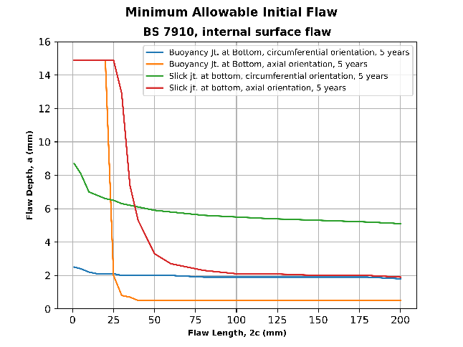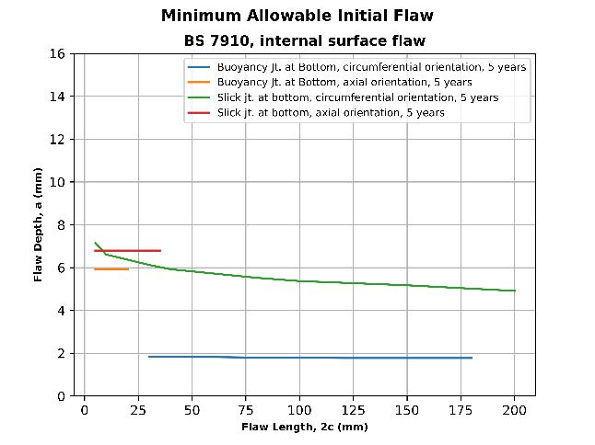

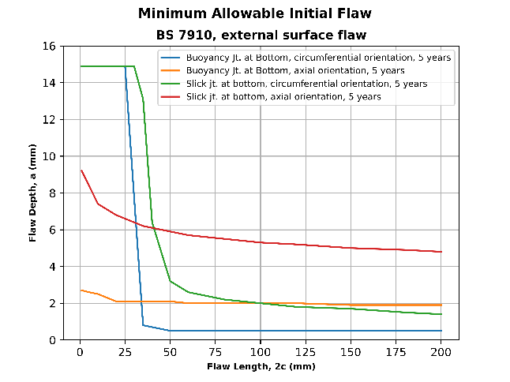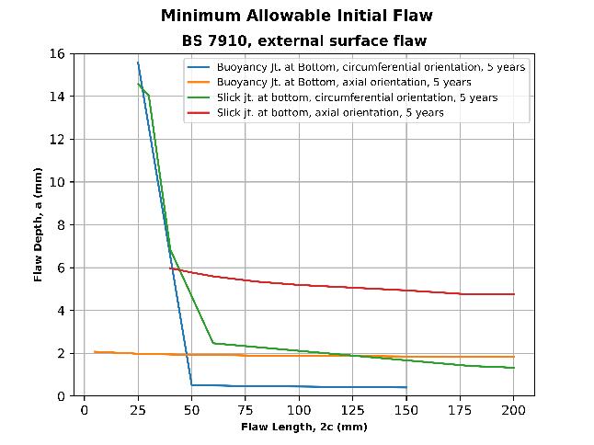

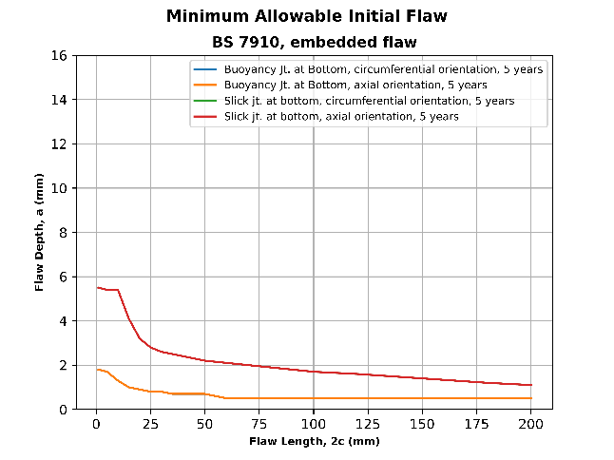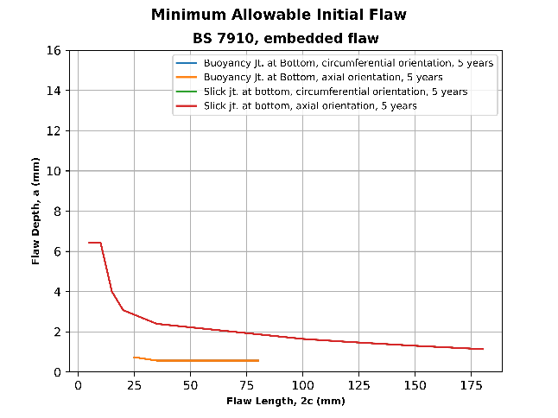

The minimum allowable flaw depth is monotonically NOT corrected. Solution below.

All Cycles Lumped vs. Time Marching Solution

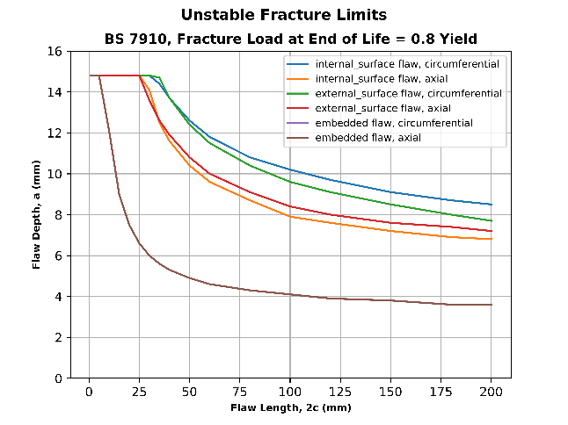







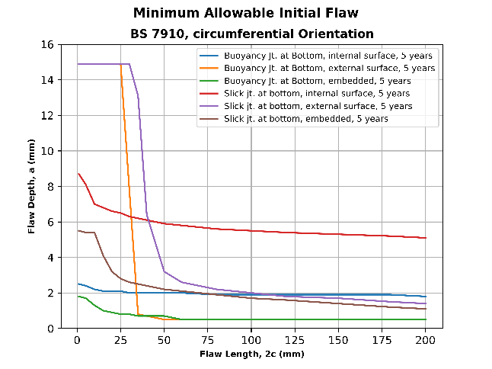 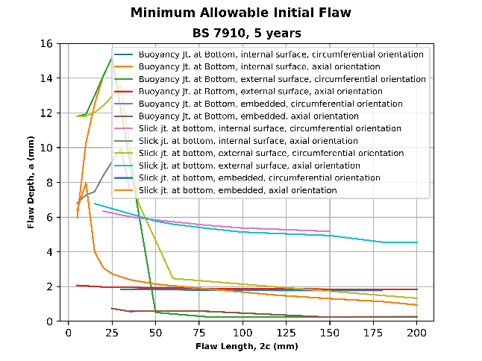

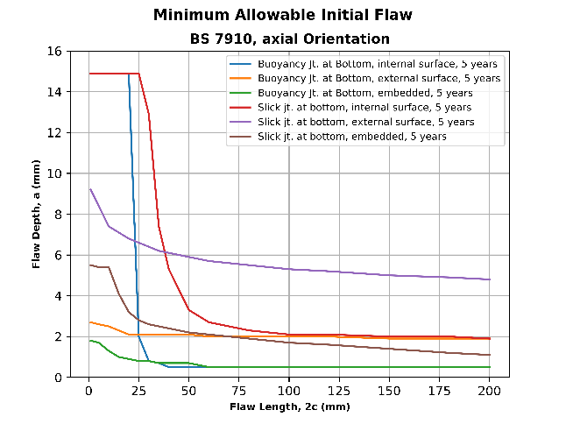

#### All Lifetime Cycles Lumped

The key simplification of the program are:

* All life cycles for the flaw lifetime are applied in the ascending order of stress range

Variable Stress Intensity Solution vs. Constant Solution

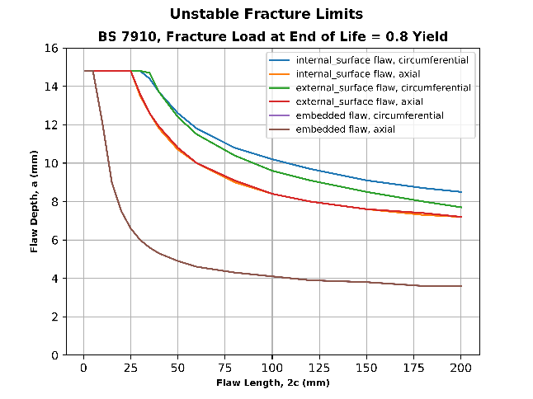

 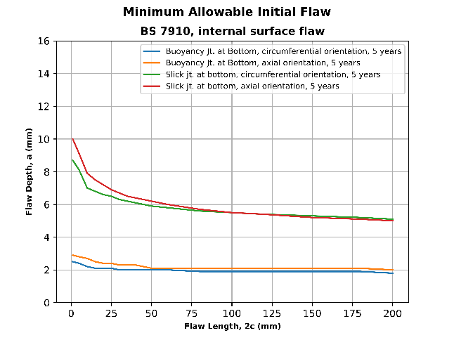







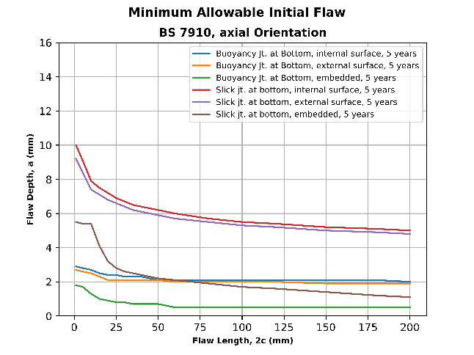

#### Constant Stress Intensity, All Lifetime Cycles Lumped

The key simplification of the program are:

* A constant stress intensity factors is utilized for all flaw dimensions
* All life cycles for the flaw lifetime are applied in the ascending order of stress range

The key conclusions are given below:

* For internal and external flaw locations, the circumferential orientation of flaw in comparison with axial orientation gives lower allowable initial flaw size for smaller flaw length and higher initial flaw size at larger flaw lengths.
* For embedded flaw size the loading is too high to determine any trend difference between the flaw orientations.
* The minimum allowable flaw size is larger than unfracture limit at low flaw lengths and this phenomenon needs to be verified.

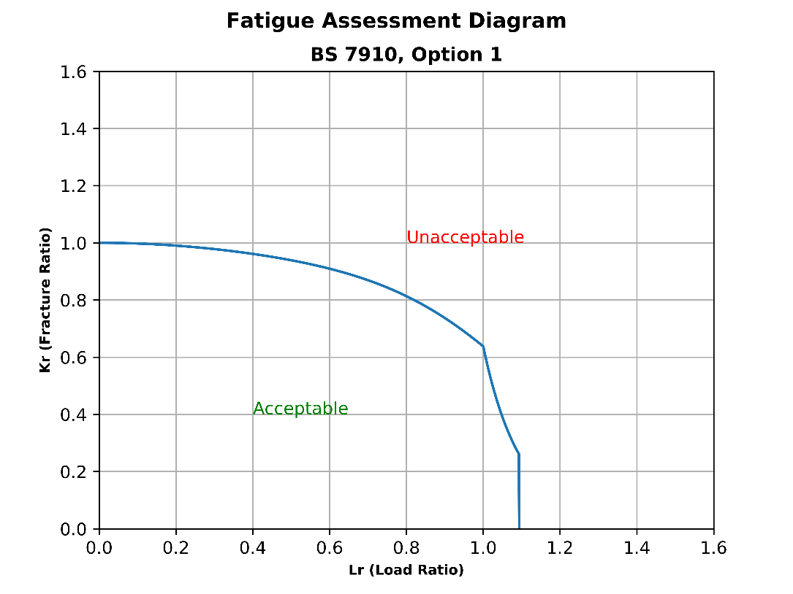

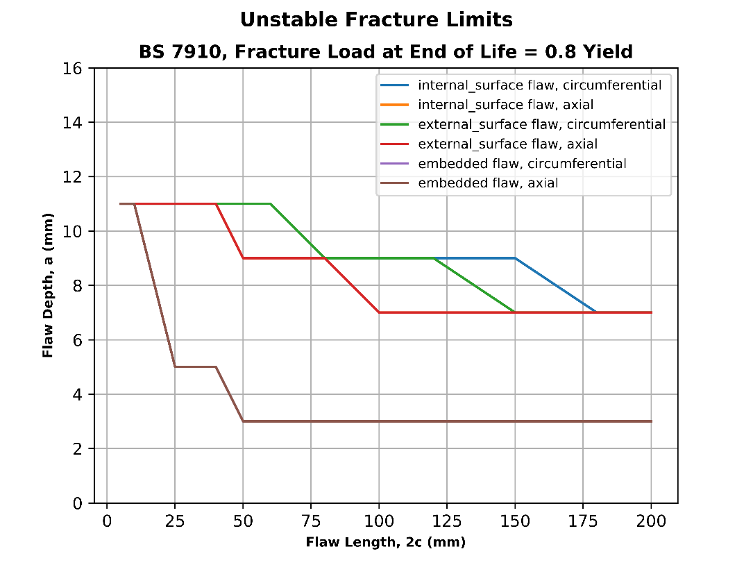

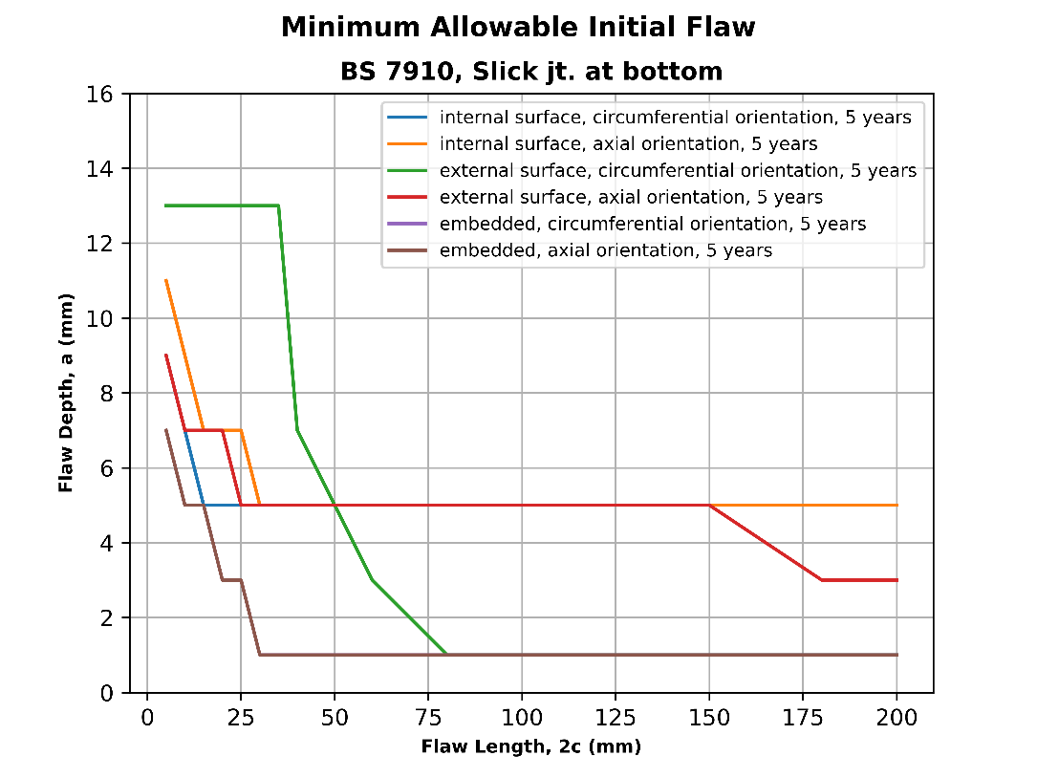

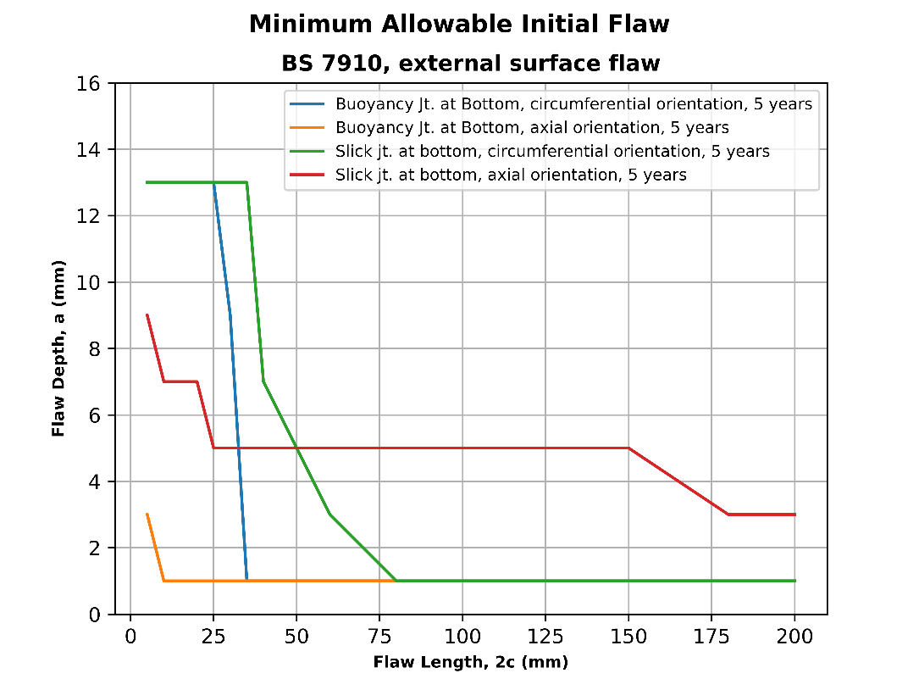

# BS7910 2013

## FAD

|  |  |  |  |  |
| --- | --- | --- | --- | --- |
|  |  |  |  |  |
|  |  |  |  |  |
|  |  |  |  |  |
|  |  |  |  |  |

Table 3‑1 : Fatigue Assessment Diagram (FAD)

## Flaw Geometries

|  |  |  |  |
| --- | --- | --- | --- |
| Flaw location |  | Orientation | Figure with BS7910-2013, Reference |
| Through-thickness | General (plate, etc) | n/a |  |
| Edge | General (plate, etc) | n/a |  |
| Surface | General (plate, etc) | n/a |  |
| Extended | General (plate, etc) | n/a |  |
| Embedded | General (plate, etc) | n/a |  |
| Corner | General (plate, cylinder, etc) | n/a |  |
| Corner | Hole geometry | n/a |  |
| Through-thickness | Cylinder | Axial |  |
| Internal surface | Cylinder | Axial |  |
| Extended Internal Surface | Cylinder | Axial |  |
| External surface | Cylinder | Axial |  |
| Extended external Surface | Cylinder | Axial |  |
| Through-thickness | Cylinder | Cicumferential |  |
| Internal surface | Cylinder | Cicumferential |  |
| Extended Internal Surface | Cylinder | Cicumferential |  |
| Extended External Surface | Cylinder | Cicumferential |  |
| Through-thickness | Spherical Shell |  |  |
| Flaw | Bars  Bolts |  |  |

## Stress Intensity Solutions

?

## Reference Stress

|  |  |  |  |  |  |  |  |  |  |
| --- | --- | --- | --- | --- | --- | --- | --- | --- | --- |
| **Component** | | **Flaw Location** | **Flaw Orientation** | **Loading Type** | **Reference Stress** | **Reference Stress Annex** | **Stress Intensity Solution Annex** | **Limit Load** | **In Python?** |
|  | **Flat Plate Component** | | | | | | | | |
| Flat Plate | | Through-thickness | n/a | Tension +  Bending |  | P.6.1 |  |  |  |
| Flat Plate | | Surface | n/a | Tension +  Bending |  | P.6.1 |  |  |  |
| Flat Plate | | Extended Surface | n/a | Tension +  Bending |  | P.6.2 |  |  |  |
| Flat Plate | | Embedded | n/a | Tension +  Bending |  | P.6.3 |  |  |  |
| Flat Plate | | Extended Embedded | n/a | Tension +  Bending |  | P.6.4 |  |  |  |
| Flat Plate | | Corner | n/a | Tension +  Bending |  | P.7.1 |  |  |  |
| Flat Plate | | Corner flaws at hole | n/a | Tension +  Bending |  | P.7.2 |  |  |  |
| Flat Plate | | Single Corner flaw at hole | n/a | Tension +  Bending |  | P.7.3 |  |  |  |
| **Thin-walled pipe/cylinder** | |  |  |  |  |  |  |  |  |
| Thin-walled pipe/cylinder | | Through-thickness | Axial | Membrane + through-wall |  | P.9.1 |  |  |  |
| Thin-walled pipe/cylinder | | Internal Surface | Axial | Membrane + through-wall |  | P.9.2 |  |  |  |
| Thin-walled pipe/cylinder | | Internal Surface | Axial | Membrane + through-wall + Internal Pressure | Equation P.18 | P.9.2 | M7.2.2 |  | Yes |
| Thin-walled pipe/cylinder | | Extended Internal Surface | Axial | Membrane + through-wall |  | P.9.3 |  |  |  |
| Thin-walled pipe/cylinder | | External Surface | Axial | Membrane + through-wall | Equation P.18 | P.9.4 | M7.2.4 |  | Yes |
| Thin-walled pipe/cylinder | | Extended External Surface | Axial | Membrane + through-wall |  | P.9.5 |  |  |  |
| Thin-walled pipe/cylinder | | Embedded | Axial | Membrane + through-wall | Equation P.11 | P.10.6 | M.7.3.6 Refers to  M4.3 |  | Yes |
| Thin-walled pipe/cylinder | | Through-thickness | Circumferential | Membrane + through-wall + Internal Pressure |  | P.10.1 |  |  |  |
| Thin-walled pipe/cylinder | | Internal Surface | Circumferential | Membrane + through-wall + Internal Pressure | Equation P.23 | P.10.2 | M.7.3.2 |  | Yes |
| Thin-walled pipe/cylinder | | Extended Internal Surface | Circumferential | Membrane + through-wall + Internal Pressure |  | P.10.3 |  |  |  |
| Thin-walled pipe/cylinder | | External Surface | Circumferential | Membrane + through-wall + Internal Pressure | Equation P.23 | P.10.4 | M.7.3.4  Refers to  M4.1 |  | Yes |
| Thin-walled pipe/cylinder | | Extended External Surface | Circumferential | Membrane + through-wall + Internal Pressure |  | P.10.5 |  |  |  |
| Thin-walled pipe/cylinder | | Embedded | Circumferential | Membrane + through-wall + Internal Pressure | Equation P.11 | P.10.6 | M.7.3.6  Refers to  M4.3 |  | Yes |
| **Thick-walled pipe/cylinder** | |  |  |  |  |  |  |  |  |
| Thick-walled pipe/cylinder | | Through-thickness | Axial | Membrane + through-wall |  | ?? |  |  |  |
| Thick-walled pipe/cylinder | | Internal Surface | Axial | Membrane + through-wall |  | P.9.2 |  |  |  |
| Thick-walled pipe/cylinder | | Internal Surface | Axial | Internal Pressure |  | P.9.6 |  |  |  |
| Thick-walled pipe/cylinder | | Extended Internal Surface | Axial | Membrane + through-wall |  | P.9.3 |  |  |  |
| Thick-walled pipe/cylinder | | External Surface | Axial | Internal Pressure |  | P.9.7 | N/A |  | Yes Check? |
| Thick-walled pipe/cylinder | | Extended External Surface | Axial | Membrane + through-wall |  | P.9.5 |  |  |  |
| Thick-walled pipe/cylinder | | Embedded | Axial | Membrane + through-wall | Equation P.11 |  |  |  | Yes Check? |
| Thick-walled pipe/cylinder | | Through-thickness | Circumferential | Membrane + through-wall + Internal Pressure |  | P.10.1 |  |  |  |
| Thick-walled pipe/cylinder | | Internal Surface | Circumferential | Membrane + through-wall + Internal Pressure |  | P.10.2 |  |  |  |
| Thick-walled pipe/cylinder | | Extended Internal Surface | Circumferential | Membrane + through-wall + Internal Pressure |  | P.10.3 |  |  |  |
| Thick-walled pipe/cylinder | | External Surface | Circumferential | Membrane + through-wall + Internal Pressure |  | P.10.4 |  |  |  |
| Thick-walled pipe/cylinder | | Extended External Surface | Circumferential | Membrane + through-wall + Internal Pressure |  | P.10.5 |  |  |  |

Table 3‑2 :

# references

<https://www.twi-global.com/technical-knowledge/published-papers/bs-7910-history-and-future-developments-july-2009>

<http://www.twitraining.com/home/programmes-and-courses/other-specialised-engineering-courses/structural-integrity-assessment>

<https://www.youtube.com/watch?v=4PdAxS8NgU8>

<https://www.youtube.com/watch?v=tlE3eK0g6vU>

<http://www.fleetech.com/products/flawcheck-structural-integrity-management-software/>

<http://ijcoe.org/article-1-30-en.pdf>

<https://www.aimspress.com/article/10.3934/matersci.2016.4.1649/fulltext.html>

AFRL-VA-WP-TR-2003-3002, "USAF Damage Tolerant Design Handbook: Guidelines for the Analysis and Design of Damage Tolerant Aircraft Structures," 2002

API 579-1 / ASME FFS-1, "Fitness-For-Service," The American Petroleum Institute and The American Society of Mechanical Engineers, 2007

Anderson, T.L., "Fracture Mechanics: Fundamentals and Applications," 3rd Edition

Dowling, Norman E., "Mechanical Behavior of Materials: Engineering Methods for Deformation, Fracture, and Fatigue," 3rd Edition

Liu, Alan F., "Structural Life Assessment Methods," ASM International, 1998

MIL-HDBK-5J, "Metallic Materials and Elements for Aerospace Vehicle Structures," Department of Defense Handbook, 2003

NASA-STD-5009, "Nondestructive Evaluation Requirements for Fracture-Critical Metallic Components," 2008

Naval Sea Systems Command, "Fracture Toughness Review Process for Metals in Critical Non-Nuclear Shipboard Applications," 1998

Sanford, R.J., "Principles of Fracture Mechanics," 1st Edition

– PROGRAM HISTORY

## Revision History

|  |  |  |
| --- | --- | --- |
| Revision Date | Features |  |
|  |  |  |

Figure 4‑1.Program History

- App Flowchart

The flow chart will help identify are the key calculations we can avoid repetition of?

evaluate_FAD

Evaluates the fatigue assessment diagram with material properties (yield, ultimate, strain properties) ~5 scritical_flaw_limits: calculates critical flaw at failure (3 s)

get_initial_flaw_for_fatigue_loading

initial flaw due to fatigue loading. This needs to be converted to march in time 0.1 years etc. (factor of 10 to 50 times) - Catch 1 flaw size (min). Find what is the minimum flaw acceptable at that juncture.- Reduce loading condition matrix (flaw geometry, flaw type to sungle value)

- ERROR LOG

|  |  |  |
| --- | --- | --- |
|  |  |  |
|  |  |  |
|  |  |  |
|  |  |  |

Figure 4‑2.Error Log.

Calculation Errors

The typical errors encountered while running the calculation program are given in this section.

-test cases.

The program got to handle discontinuities as shown in figure below.

Figure 4‑3.Test Cases.

– External Programs

External programs referenced or benchmarked are outlined in this section.

Mechanicalc

<https://mechanicalc.com/calculators/fracture-materials/>

<https://mechanicalc.com/reference/fatigue-crack-growth>